Software Requirements Specification

for

Fitness365

Prepared by

Md. Abdullah Al Jobaer 1512028042

Md. Jushraf Rahman Chowdhury 1812901042

Mahjabin Siddique 1813201642

E-Corps

Date created: 04/08/2020

Table of Contents

Table of Contents ii

Revision History ii

1. Introduction 1

1.1 Purpose 1

1.2 Document Conventions 1

1.3 Intended Audience and Reading Suggestions 1

1.4 Product Scope 1

1.5 References 1

2. Overall Description 2

2.1 Product Perspective 2

2.2 Product Functions 2

2.3 User Classes and Characteristics 2

2.4 Operating Environment 2

2.5 Design and Implementation Constraints 2

2.6 User Documentation 2

2.7 Assumptions and Dependencies 3

3. External Interface Requirements 3

3.1 User Interfaces 3

3.2 Hardware Interfaces 3

3.3 Software Interfaces 3

3.4 Communications Interfaces 3

4. System Features 4

4.1 System Feature 1 4

4.2 System Feature 2 (and so on) 4

5. Other Nonfunctional Requirements 4

5.1 Performance Requirements 4

5.2 Safety Requirements 5

5.3 Security Requirements 5

5.4 Software Quality Attributes 5

5.5 Business Rules 5

6. Other Requirements 5

Appendix A: Glossary 5

Appendix B: Analysis Models 5

Appendix C: To Be Determined List 6

Revision History

|  |  |  |  |
| --- | --- | --- | --- |
| **Name** | **Date** | **Reason For Changes** | **Version** |
|  |  |  |  |
|  |  |  |  |

**1. Introduction**

**1.1 Purpose:**

Purpose of Software Requirements Specification (SRS) is to describe the specific descriptions of our project ''Fitness365''. This Software Requirements Specification illustrates in clear terms of system's primary uses and required functionality so that the next developers can easily understand what we did and how to change anything if it is required.

**1.2 Document Convention:**

Main Titles: Font: Calibri, Face: Bold, Size: 18

Sub Section Titles: Font: Calibri, Face: Bold, Size: 14

Other Explanations: Font: Calibri, Face: Normal, Size: 12

**1.3 Intended Audience and Reading Suggestions:**

This Software Requirements Specification (SRS) is designed for Software Designer, Software Developers, Software Tester and for Project Manager. It is required for everyone to read through all the pages of this SRS.

**1.4 Product Scope:**

Fitness365 is a platform where a person can easily maintain his fitness by following our suggestions and keep track of his progress by using it's features. When a user log in to this app, the app will show his daily workout routine and diet chart. It will also notified him during his advised time. On the other side the admin can also get many benefits by using this app. Such as, he can see the monetary transactions with the net profit or loss. Admin will be able to see the unpaid and obese members. He can also upload customized workout and diet chart to the clients.

**1.5 References:**

Google.com

**2. Overall Description:**

**2.1 Product Perspective:**

This product is not a follow-on member of any product family but a replacement of the existing gym and fitness management system.

Fitness365 will digitalize all the processes that occur between a gym-owner (admin) and its members (user) in a very personalized manner. The admin will be able to send the users customized diet-chart, workout plan, track their payment and attendance pattern. The users will be able to pay their gym membership fee, view the diet/workout plan assigned to them

**2.2 Product Functions:**

The product functions are given below:

* Gym manager can assign customized diet chart and workout routine to clients.
* Clients will be reminded of their diet chart in the designated time of the day via push notifications
* Clients will be able to view their workout routine, pay membership fee, submit attendance.
* Gym manager can track their payment records and attendance.
* The system will generate an automated report based on the change in pattern of user attendance.

**2.3 User Clases and Characteristics**

There will be three types of user classes: Admin, User and System

Admin will :

* Login/Logout
* Register/Delete User
* Send customized diet chart and workout routine to users.
* Track payment status and attendance

Users will :

* Login/Logout
* View their workout routine and diet chart
* Pay membership fee
* Submit attendance
* View payment history

System will:

* Generate attendance report based on user attendance pattern
* Generate push notifications to remind user about diet-chart

**2.4 Use Case Diagram**

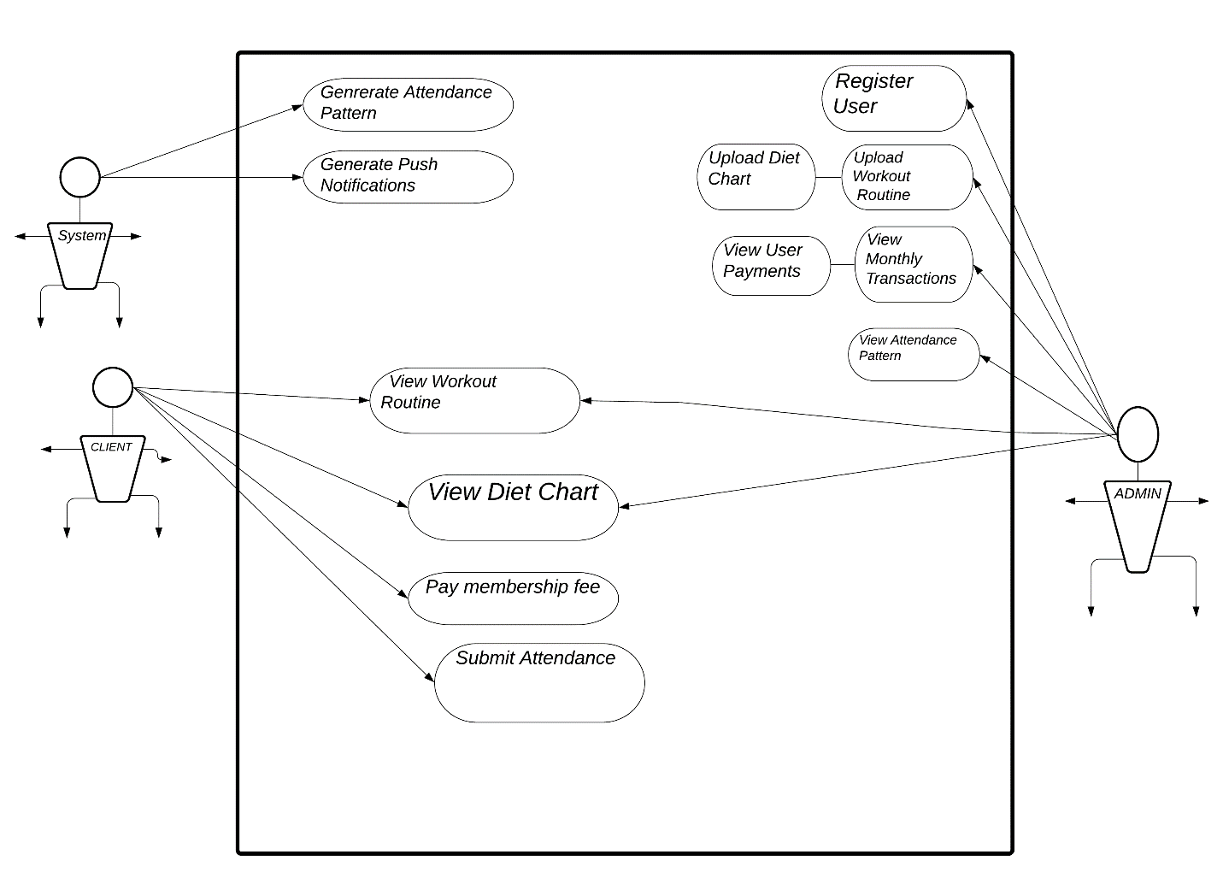

**2.5 Operating Environment:**

* Platform: Web and android
* Operating System: Any which supports modern browsers i.e Chrome, Firefox, etc.

**2.6 Design & Implementation Constraints:**

* Efficiently tracking the user attendance pattern will be a design constraint.
* Users must have stable internet connection otherwise data transfer will not occur.

**2.7 User Documentation:**

There will be two separate user manuals, one for the admin and the other for the clients which will state all the functionalities of their respective user modes.

**2.8 Assumptions and Dependencies**

The payment feature is dependent on Bkash API as of now. Any changes made to that by Bkash themselves will affect it. Users must have stable internet connection to receive notifications regarding their diet and workout plan.

**3. External Interface Requirements**

**3.1 User Interfaces**

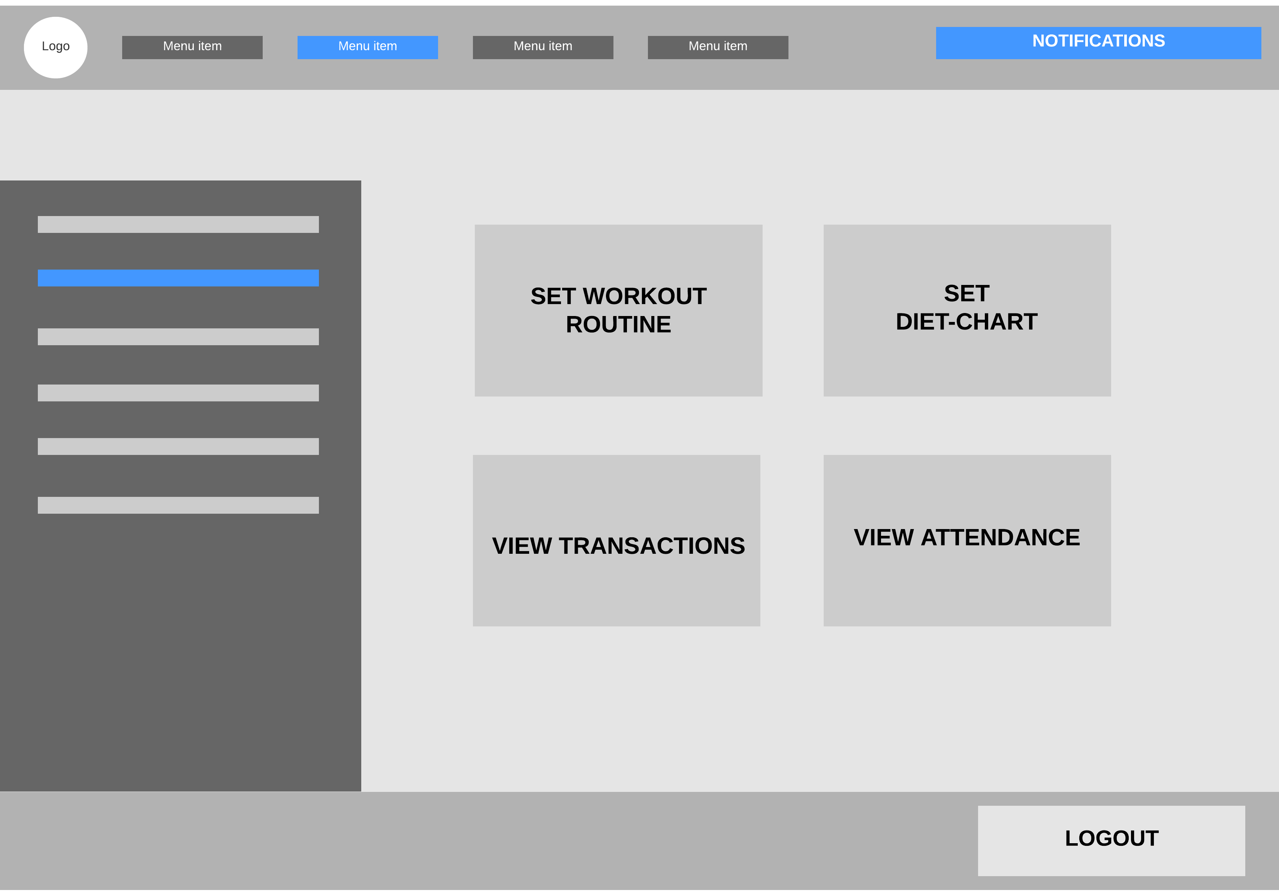

**3.2 Hardware Interfaces**

There are no exclusive hardware requirements. The product will be supported by all kinds of smartphones.

**3.3 Software Interfaces**

Browsers that support HTML5,CSS3 and JavaScript will ensure the optimal interaction and responsiveness of the website.

**3.4 Communications Interfaces**

The browser and the operating system will handle the communication between different parts of the software.

**4. Features**

**4.1 User registration:**

Actor: User

Purpose: Register the user information

OVERVIEW: Given that a user has downloaded the mobile application, or accessed the website then the user should be able to register into the system. The user must provide Full Name, Password, Height, weight, address Phone Number and user type. User type consist of 'Admin', 'Member'.

COURSE OF EVENTS:

I) Open the application or website

II) Select "Sign Up" button

III) Enter all the information

IV) Click on Sign Up

ALTERNATIVE COURSE OF EVENTS:

I) Email does not match, show error: Please provide a valid email.

II) Password is less than 6 digits, show error: Password must include at least 6 digits.

III) Any field left blank, show error: All the fields must be filled up.

**4.2 View workout routine**

Actor: Member

OVERVIEW: Show the daily workout routine to the member.

COURSE OF EVENTS:

I) Select "Today's Workout" button

**4.3 View Diet chart**

Actor: Member

OVERVIEW: Show the specific diet chart to the member.

COURSE OF EVENTS:

I) Select "My Diet chart" button

**4.4 View transaction**

Actor: Admin

OVERVIEW: Show the net profit or loss to the admin.

COURSE OF EVENTS:

I) Select "Transaction" button

**4.5 View Unpaid/Obese Members**

Actor: Admin

OVERVIEW: Show all the members with the specification of unpaid and obese members.

COURSE OF EVENTS:

I) Select "Members" button

**4.6 Set Diet chart**

ACTOR: Admin

OVERVIEW: The admin will be able to create a diet chart according to individual member's progress and also can remove or edit existing one.

COURSE OF EVENTS:

I) Create a new Diet chart

II) Edit existing Diet chart

III)Remove existing Diet chart

ALTERNATIVE COURSE OF EVENTS:

I) No Diet chart to edit or delete

**4.7 Set Workout Routine**

ACTOR: Admin

OVERVIEW: The admin will be able to create a workout chart according to individual member's progress and also can remove or edit existing one.

COURSE OF EVENTS:

I) Create a new workout chart

II) Edit existing workout chart

III)Remove existing workout chart

ALTERNATIVE COURSE OF EVENTS:

I) No workout chart to edit or delete

**4.8 Attendance**

ACTOR: Admin

OVERVIEW: The admin will be able to check and take the members attaendance and based on this it will generate an automated report.

COURSE OF EVENTS:

I) Select "Attendance" button

II) Select "Take Attendance" button

III) Check Attendance

**4.9 Download mobile application**

ACTOR: User

OVERVIEW: A user should be able to download the mobile application through either an application store or similar service on the mobile phone. The application should be free to download.

COURSE OF EVENTS:

I) Downloads the app from google play store

**4.10 Check Password**

ACTOR: System

OVERVIEW: Match password entered by the user during login. The inserted password will be matched against the one stored in the database.

COURSE OF EVENTS:

I) Get password from user

II) Get password from databases

III) Match if both the passwords are the same.

ALTERNATIVE COURSE OF EVENTS:

I) The errors will be handled by the view using this function

**4.11 Profile Page**

Actor: User

OVERVIEW: Show the user information to the user. This information will include, name, email, phone number, Height, weight, address and user type. User will be able to modify any of this information except for the mail.

COURSE OF EVENTS:

I) Select Profile button from home

II) Select any field

III) Modify the selected field

IV) Click on update information

ALTERNATIVE COURSE OF EVENTS:

I) Data not downloaded properly, show error: Couldn't connect to server, please check your internet connection and try again later!

**4.12 User Login**

Actor: User

OVERVIEW: Given to them whom are already registered, the user will be able to login with their email and password.

COURSE OF EVENTS:

I) Select "Sign In" button

II) Enter email and password

III) Click on login

ALTERNATIVE COURSE OF EVENTS:

I) Email not exist, show error: This email is not registered yet. Please Register first.

II) Password does not match, show error: Password or email is not correct. Please retry!

III) Any field left blank, show error: All the fields must be filled up

**5. Other Nonfunctional Requirements**

Apart from the various functional requirements, the product needs to be fast while generating results from the search section.

**5.1 Performance Requirements:**

The system can provide ease both at admin and user level. We as a team focus on program logic to done the require task in systematic, disciplined and in quantifiable approach.

This application will run smoothly on Android KitKat (and above) and ios 12+

A RAM of 2gb and above are recommended.

**5.2 Safety Requirement:**

The system will ensure that no data is lost in case the user decides to change his/her devices. It will also ensure not to lose any data even when the user’s device is damaged somehow. Then all data will be stored in system’s cloud storages. The system will help to maintain the privacy of user by best possible encryption method techniques.

**5.3 Security Requirement:**

The system should secure the privacy of the users. Thus, it shall not disclose any personal information about the users. The system shall not grant any kind of access to an unauthorized user and shall not communicate with any other devices and servers while getting used by the user.

**5.4 Software Quality Attributes:**

The requirements in this section specifies the reliability, availability and maintainability of the software system.

i. The application shall not crash or close under any circumstances.

ii. The application shall be able to recover in the event of a system failure in at least the time it takes to close the application and restart. It shall recover after a system crash in no longer than 5 minutes.

iii. The application shall always be available to be used by the user.

iv. The application shall be maintained and modified by the developers if the application is found to have a flaw or bug.

v. The application shall be modified with only minor changes to previous code.

**6. Other Requirements**

**6.1 Appendix A: Glossary**

Provides definitions of unfamiliar terms, acronyms and abbreviations

**6.2 Appendix B: Analysis Models**

Our plan is to include class diagram after the basic protype is finished.

**6.3 Appendix C: To Be Determined List**